CLASSICAL ENCRYPTION TECHNIQUES : There are two basic building blocks of all encryption techniques: substitution and transposition.
SUBSTITUTION TECHNIQUES : A substitution technique is one in which the letters of plaintext are replaced by other letters or by numbers or symbols. If the plaintext is viewed as a sequence of bits, then substitution involves replacing plaintext bit patterns with cipher text bit patterns.
Caesar cipher (or) shift cipher:
The earliest known use of a substitution cipher and the simplest was by Julius Caesar.
The Caesar cipher involves replacing each letter of the alphabet with the letter standing 3 places further down the alphabet.
e.g., plain text : pay more money
Cipher text: SDB PRUH PRQHB
Note that the alphabet is wrapped around, so that letter following z is a.
For each plaintext letter p, substitute the cipher text letter c such that
C = E(p) = (p+3) mod 26
A shift may be any amount, so that general Caesar algorithm is
C = E (p) = (p+k) mod26
Where k takes on a value in the range 1 to 25.
The decryption algorithm is simply
P = D(C) = (C-k) mod26
Egs: plaintext PROTOCOL.
Where a key is needed I’ll use NETWORK (you gave this earlier). For Caesar I’ll use a standard shift = 3.

1) CAESAR CIPHER (shift = 3)
Encryption
Plaintext: PROTOCOL
Alphabet positions (A=0..Z=25):
P=15, R=17, O=14, T=19, O=14, C=2, O=14, L=11
Apply Cipher = (Plain + 3) mod 26:
- P (15) → 18 → S
- R (17) → 20 → U
- O (14) → 17 → R
- T (19) → 22 → W
- O (14) → 17 → R
- C (2) → 5 → F
- O (14) → 17 → R
- L (11) → 14 → O
Ciphertext: SURWRFR O → remove spacing → SURWRFRO
Decryption
Ciphertext: SURWRFRO
Apply Plain = (Cipher − 3) mod 26:
- S (18) → 15 → P
- U (20) → 17 → R
- R (17) → 14 → O
- W (22) → 19 → T
- R (17) → 14 → O
- F (5) → 2 → C
- R (17) → 14 → O
- O (14) → 11 → L
Recovered plaintext: PROTOCOL
Characteristics
- Very easy to implement
- Only 25 possible keys → Not secure

2. MONOALPHABETIC CIPHER
Also called Simple Substitution Cipher.
Here, each letter of plaintext is mapped to a unique letter of ciphertext, but the mapping can be any permutation of the alphabet (not a fixed shift).
Example Key Mapping:
Plain : ABCDEFGHIJKLMNOPQRSTUVWXYZ
Cipher: QWERTYUIOPASDFGHJKLZXCVBNM

Encryption
Replace each plaintext letter using the key mapping.
HELLO → ITSSG
Decryption
Use reverse mapping (Cipher → Plain).
Characteristics
- Stronger than Caesar Cipher
- 26! possible keys
- Still vulnerable to frequency analysis
Eg: Plain: ABCDEFGHIJKLMNOPQRSTUVWXYZ
Cipher: Q W E R T Y U I O P A S D F G H J K L Z X C V B N M
(So A→Q, B→W, C→E, D→R, E→T, F→Y, G→U, H→I, I→O, J→P, K→A, L→S, M→D, N→F, O→G, P→H, Q→J, R→K, S→L, T→Z, U→X, V→C, W→V, X→B, Y→N, Z→M)
Encryption (apply mapping letterwise)
Plaintext: P R O T O C O L
- P → H
- R → K
- O → G
- T → Z
- O → G
- C → E
- O → G
- L → S
Ciphertext: HKGZG EGS → HKGZG EGS (no spaces) → HKGZG EGS → final HKGZG EGS → cleaned HKGZG EGS — better shown as HKGZGEGS.
Decryption:
Take ciphertext HKGZGEGS. Use reverse mapping (Cipher→Plain):
- H → P
- K → R
- G → O
- Z → T
- G → O
- E → C
- G → O
- S → L
Recovered plaintext: PROTOCOL
Note: With monoalphabetic substitution you must keep the mapping secure. Frequency analysis can break it.
3. PLAYFAIR CIPHER
A digraph substitution cipher where plaintext is encrypted two letters at a time using a 5×5 key matrix formed with a keyword.
Steps
- Choose a keyword (e.g., “NETWORK”)
- Prepare 5x5 matrix (I/J combined)
- Break plaintext into pairs
- Apply Playfair rules:
  - Same row → take letters to the right
  - Same column → take letters down
  - Rectangle → take letters in the same row, opposite corners
  - Add X between repeated letters or at end if needed
Example
Plaintext:
BALLOON → BA LX LO ON
Characteristics
- Encrypts pairs, not single letters
- Better security than Caesar/monoalphabetic
- Still vulnerable to digraph frequency attack
Eg: PLAYFAIR CIPHER (keyword = NETWORK, I/J combined)

Build 5×5 key square (keyword NETWORK, remove duplicates, fill remaining A–Z except J)
N | E | T | W | O
R | K | A | B | C
D | F | G | H | I/J
L | M | P | Q | S
U | V | X | Y | Z

Prepare plaintext into digraphs
Plaintext: PROTOCOL
Split into pairs (two letters each): PR | OT | OC | OL
(Length is even, no padding required.)

Encryption — apply Playfair rules to each digraph
Rules reminder:
- If both letters in same row → replace each by letter to its right (wrap around).
- If both letters in same column → replace each by letter below (wrap).
- Otherwise (rectangle) → each letter replaced by the letter in the same row but in the column of the other letter (i.e., opposite corners of rectangle).
Now each pair:
Pair 1: PR
- P at (3,2) — row3,col2
- R at (1,0) — row1,col0
Rectangle → take opposite corners:
- P → (3,0) = L
- R → (1,2) = A
PR → LA
Pair 2: OT
- O at (0,4) — row0,col4
- T at (0,2) — row0,col2
Same row (row0) → replace by letters to the right:
- O (col4) → wrap to col0 = N
- T (col2) → right col3 = W
OT → NW
Pair 3: OC
- O at (0,4) (row0,col4)
- C at (1,4) (row1,col4)
Same column (col4) → replace by letters below:
- O (row0) → down row1 = C
- C (row1) → down row2 = I
OC → CI
Pair 4: OL
- O at (0,4) (row0,col4)
- L at (3,0) (row3,col0)
Rectangle → opposite corners:
- O → (0,0) = N
- L → (3,4) = S
OL → NS
Ciphertext
Concatenate pairs: LA NW CI NS → LANWCINS
Decryption (reverse Playfair rules)
Break ciphertext LANWCINS into digraphs: LA | NW | CI | NS
Reverse the rules:
- same row → shift left
- same column → shift up
- rectangle → swap columns (opposite corners again)
LA
- L (3,0), A (1,2) → rectangle → P (3,2), R (1,0) → PR
NW
- N (0,0), W (0,3) → same row → shift left:
  - N ← O (wrap) → O
  - W ← T → T
→ OT
CI
- C (1,4), I (2,4) → same column → shift up:
  - C ← O (0,4) → O
  - I ← C (1,4) → C
→ OC
NS
- N (0,0), S (3,4) → rectangle → O (0,4), L (3,0) → OL
Concatenate: PR OT OC OL → PROTOCOL
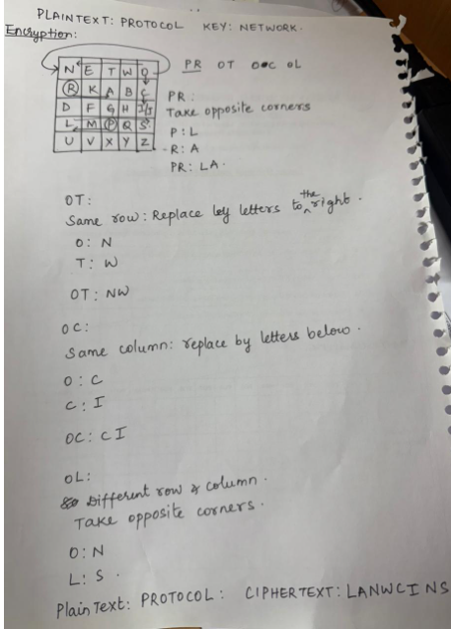

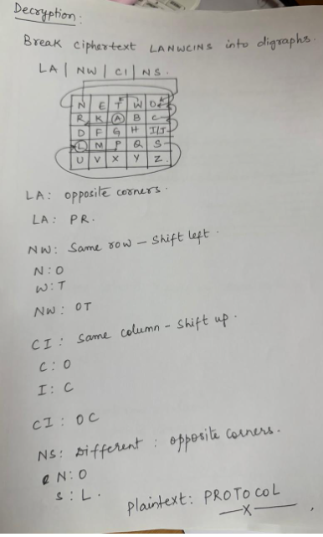

TRANSPOSITION TECHNIQUES: All the techniques examined so far involve the substitution of a cipher text symbol for a plaintext symbol.
A very different kind of mapping is achieved by performing some sort of permutation on the plaintext letters. This technique is referred to as a transposition cipher.
Rail fence : is simplest of such cipher, in which the plaintext is written down as a sequence of diagonals and then read off as a sequence of rows.
Plaintext= meet at the school house
To encipher this message with a rail fence of depth 2,
we write the message as follows:
M |  | E |  | A |  | T |  | E |  | C |  | O |  | L |  | O |  | S
 | E |  | T |  | T |  | H |  | S |  | H |  | O |  | H |  | U |  | E

The encrypted message is MEATECOLOSETTHSHOHUE
Eg:2 (Example with key = 3 rails)
Encryption Steps
Plaintext: PROTOCOL
Write letters in a zig-zag pattern with 3 rails:
P |  |  |  | O
 | R |  | T |  | C |  | L
 |  | O |  |  |  | O

CIPHERTEXT:
Join rows:
- Row 1 → P O
- Row 2 → RTCL
- Row 3 → OO
PORTCLOO

Decryption Steps:
HOW DO WE KNOW THE POSITIONS DURING DECRYPTION?
When decrypting Rail Fence Cipher, we recreate the zig-zag pattern using:
- Ciphertext length (N)
- Key (number of rails)
This zig-zag pattern tells us exactly where each letter belongs before reading the plaintext.

- Count letters = 8
- Determine the zig-zag pattern positions
- Fill ciphertext row-wise
- Read in zig-zag

STEP 1 — Make an empty zig-zag pattern
For the ciphertext PORTCLOO,
Length = 8,
Key = 3 rails
We first draw rails:
1 2 3 4 5 6 7 8
X |  |  |  | X
 | X |  | X |  | X |  | X
 |  | X |  |  |  | X
This is how we KNOW the positions.
We have not used any letters yet — only the key and length.
Count how many letters go in each rail
From the pattern:
- Rail 1 has 2 X's
- Rail 2 has 4 X's
- Rail 3 has 2 X's
So ciphertext is split:
- Rail 1: PO
- Rail 2: RTCL
- Rail 3: OO
P |  |  |  | O
 | R |  | T |  | C |  | L
 |  | O |  |  |  | O
Read in zig-zag order:
That gives:
PROTOCOL (plaintext)

2. COLUMNAR TRANSPOSITION CIPHER
We use the key: NETWORK
Step 1: Assign key order
Key:
N E T W O R K
Sort alphabetically:
E K N O R T W
1 2 3 4 5 6 7 ← numbers assigned
Mapping to original:
Letter | N | E | T | W | O | R | K
Order | 3 | 1 | 6 | 7 | 4 | 5 | 2

Step 2: Write plaintext row-wise
Plaintext: PROTOCOL (8 letters)
We have 7 columns → need 2 rows
Pad with X for missing cells:
N | E | T | W | O | R | K
P | R | O | T | O | C | O
L | X | X | X | X | X | X

Step 3: Read columns in key order
Order: 1 → 7
i.e., E, K, N, O, R, T, W
- Column E → R X
- Column K → O X
- Column N → P L
- Column O → O X
- Column R → C X
- Column T → O X
- Column W → T X
Ciphertext
Combine all:
RXOXPLOXCXOXT

Decryption Steps
- Write the key with column numbers
- Create an empty table with 2 rows × 7 columns
- Fill columns in the order of key numbers
- Read row-wise
Reconstructed table:
N | E | T | W | O | R | K
P | R | O | T | O | C | O
L | X | X | X | X | X | X
Reading row-wise → PROTOCOL
Decrypted plaintext
PROTOCOL

